**Design the DFA for following**

1.construct the DFA with odd number of 1’s and any number of zeros

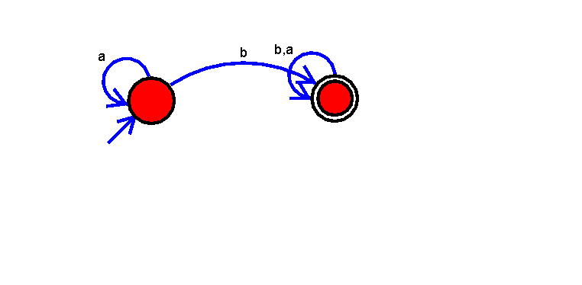

2.binary string having even no,of 1’s and 0’s

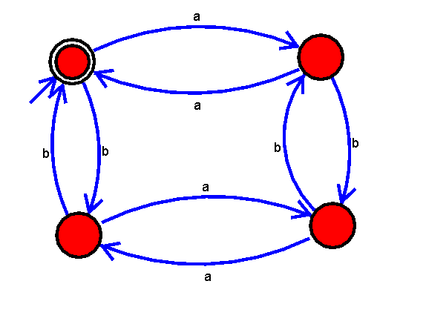

1.3. construct the dfa substring 101

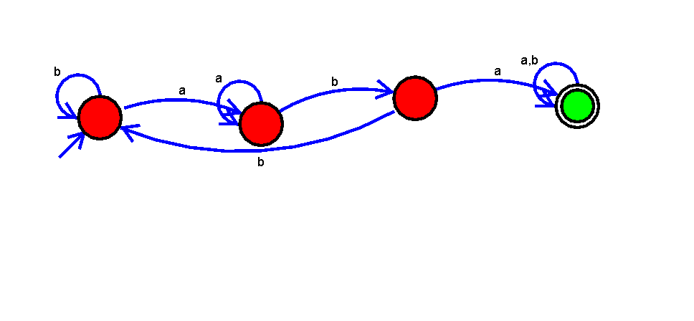

1.4 .contruct the DFA having no conjucative zeros

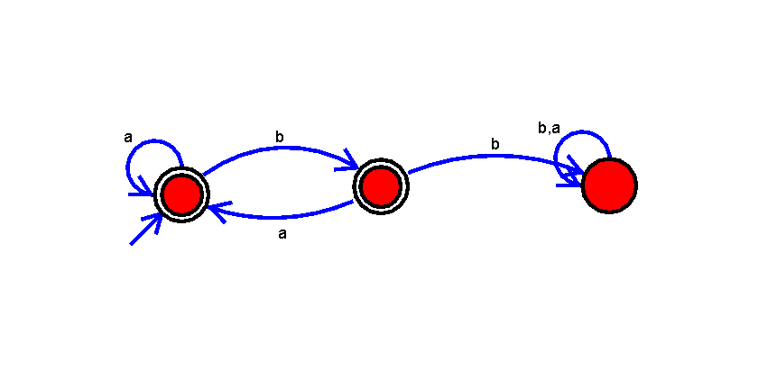

**Design The NFA For The Following**:

2.1 binary string having the 00’s substring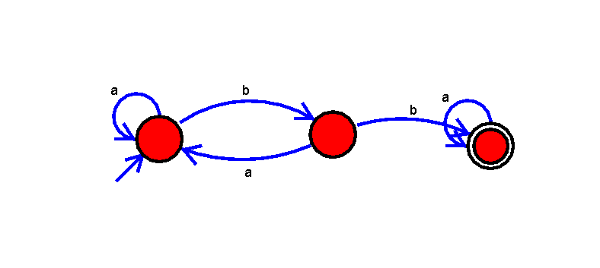

2.2 binary string having start with 0’s and end with 0’s

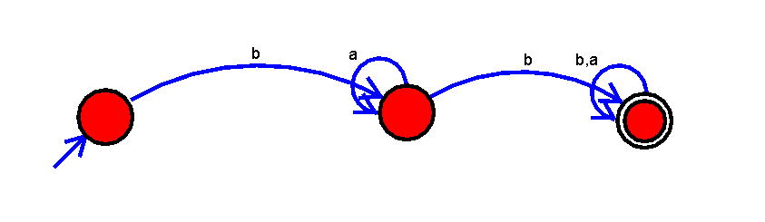

2.3 construct binary string having start and end with different number

